Refactoring List for build 3 – Team 7

## We have revised the map test to make each test case independent from each other.

Using i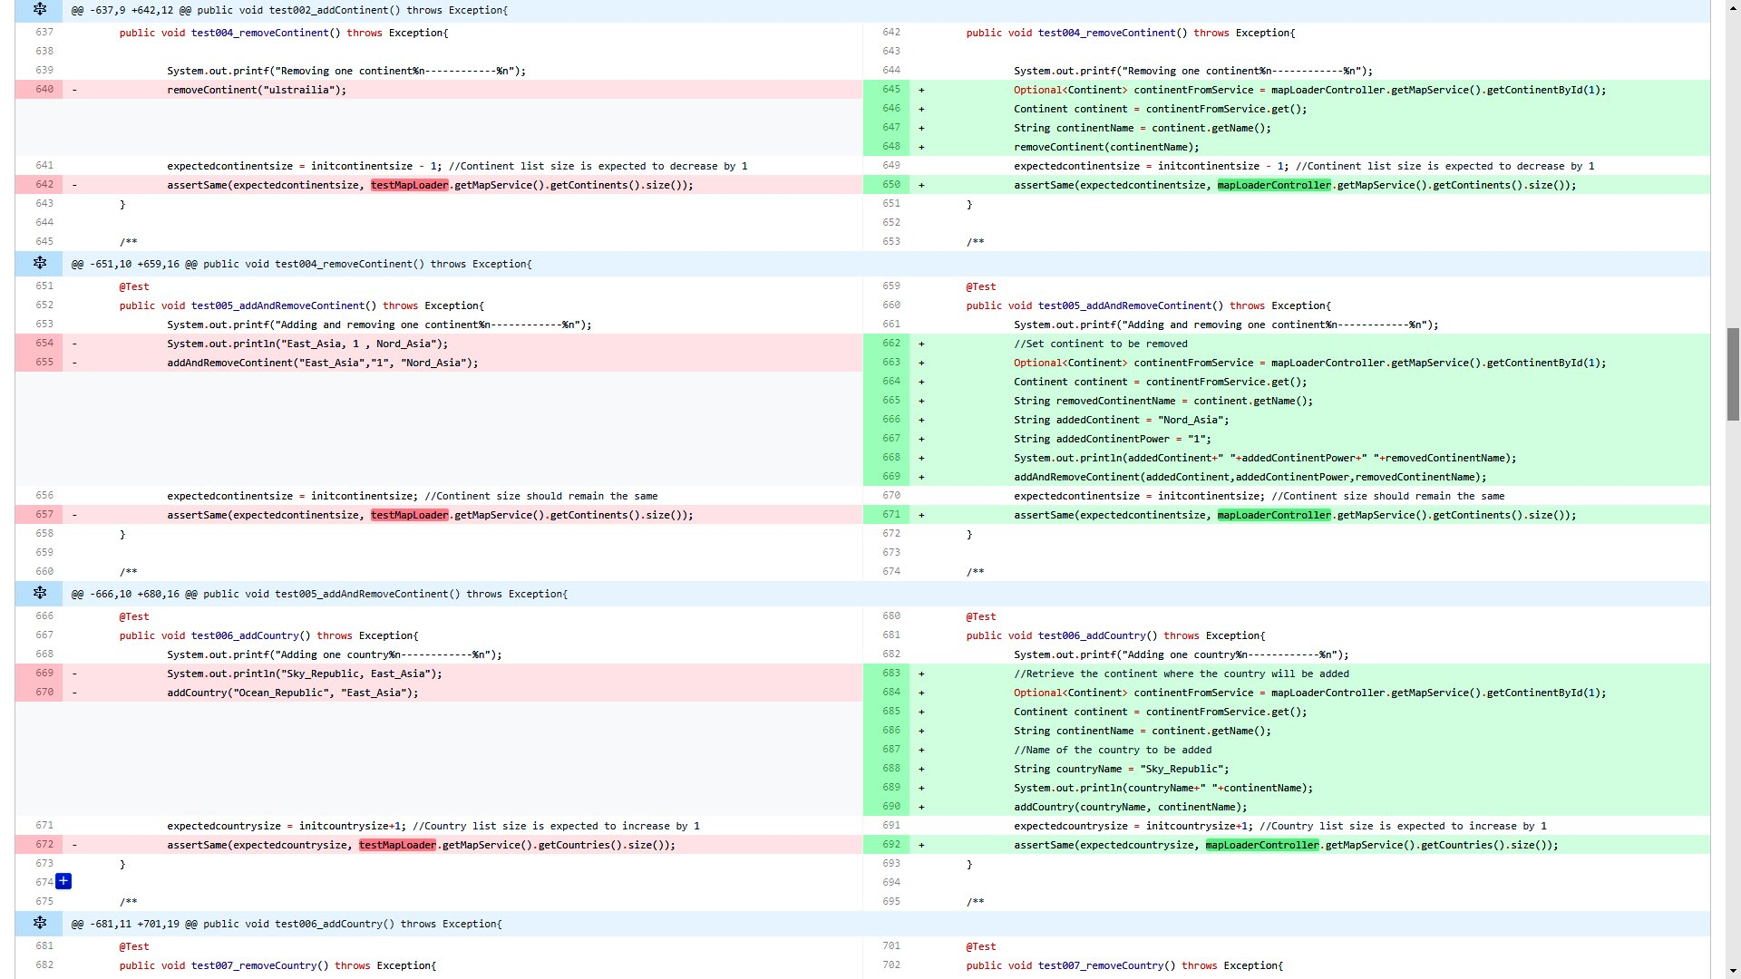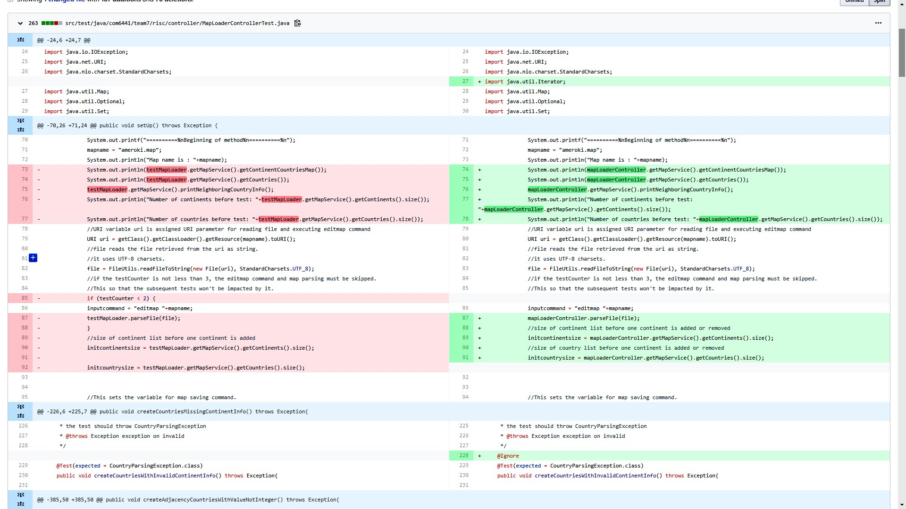terator type to dynamically traverse through list of countries in map file.

Removed all the hardcoding specific to a map file.

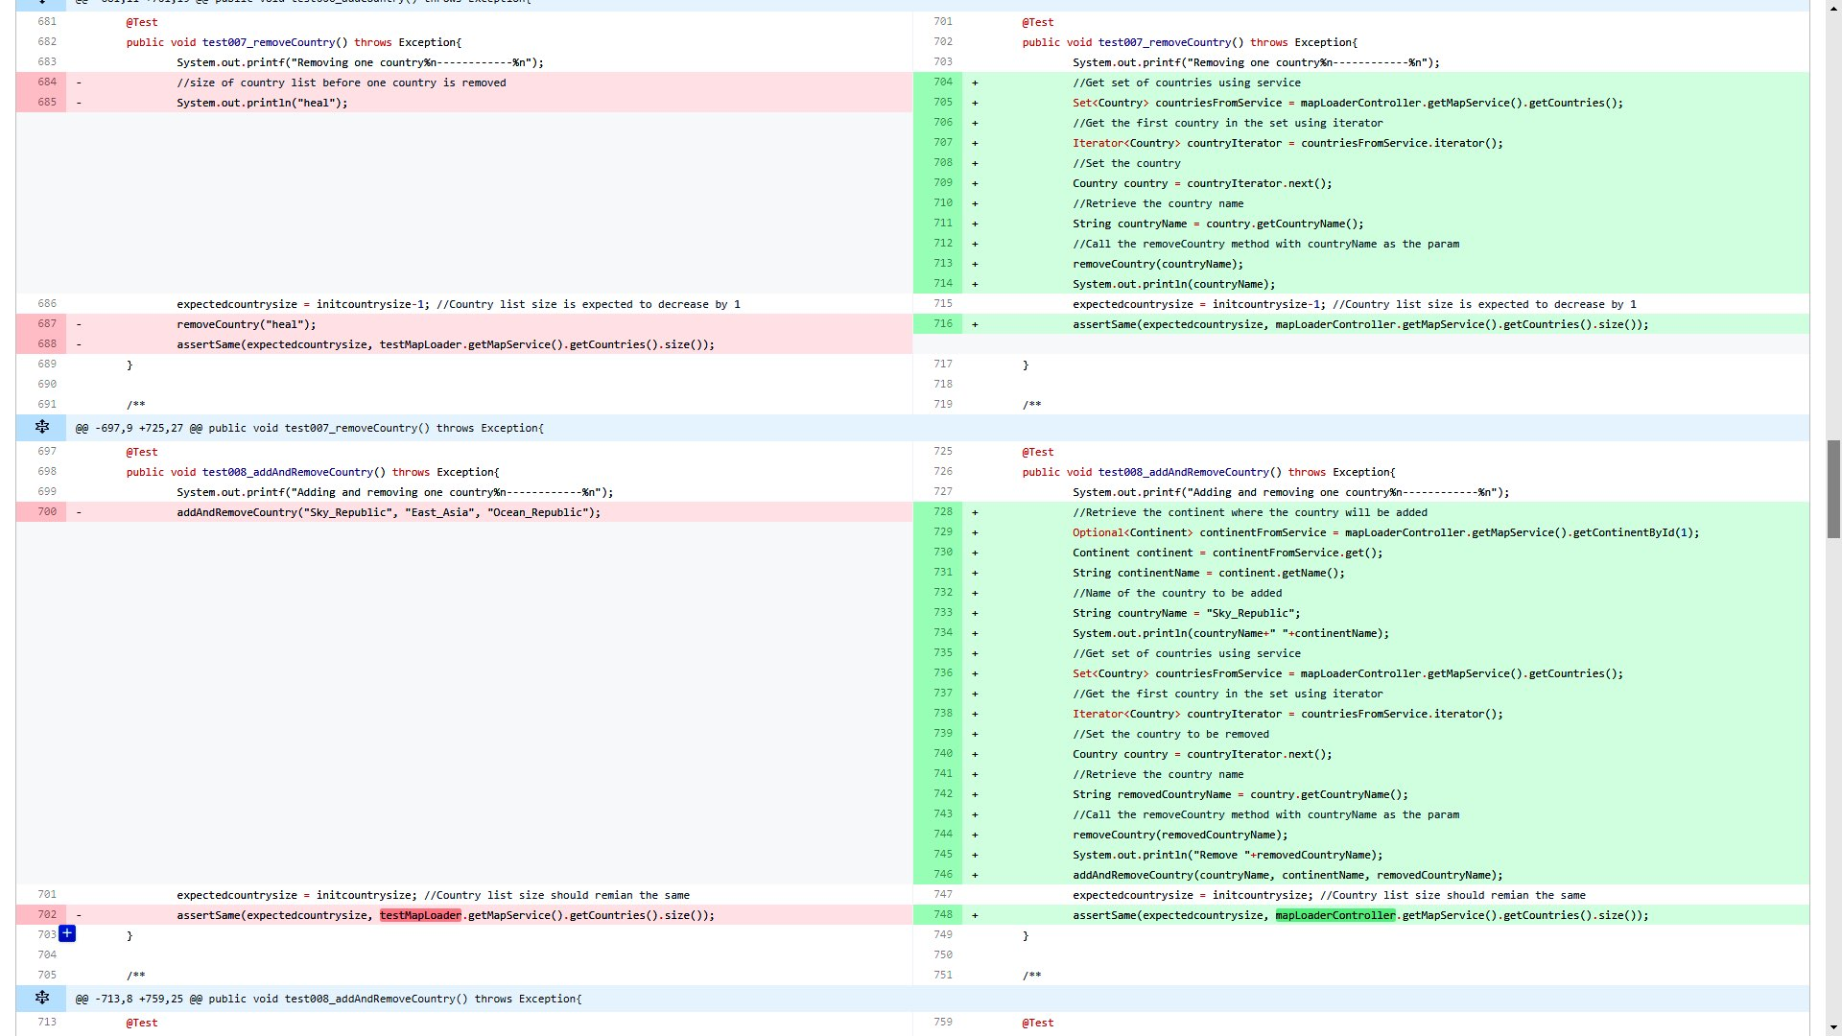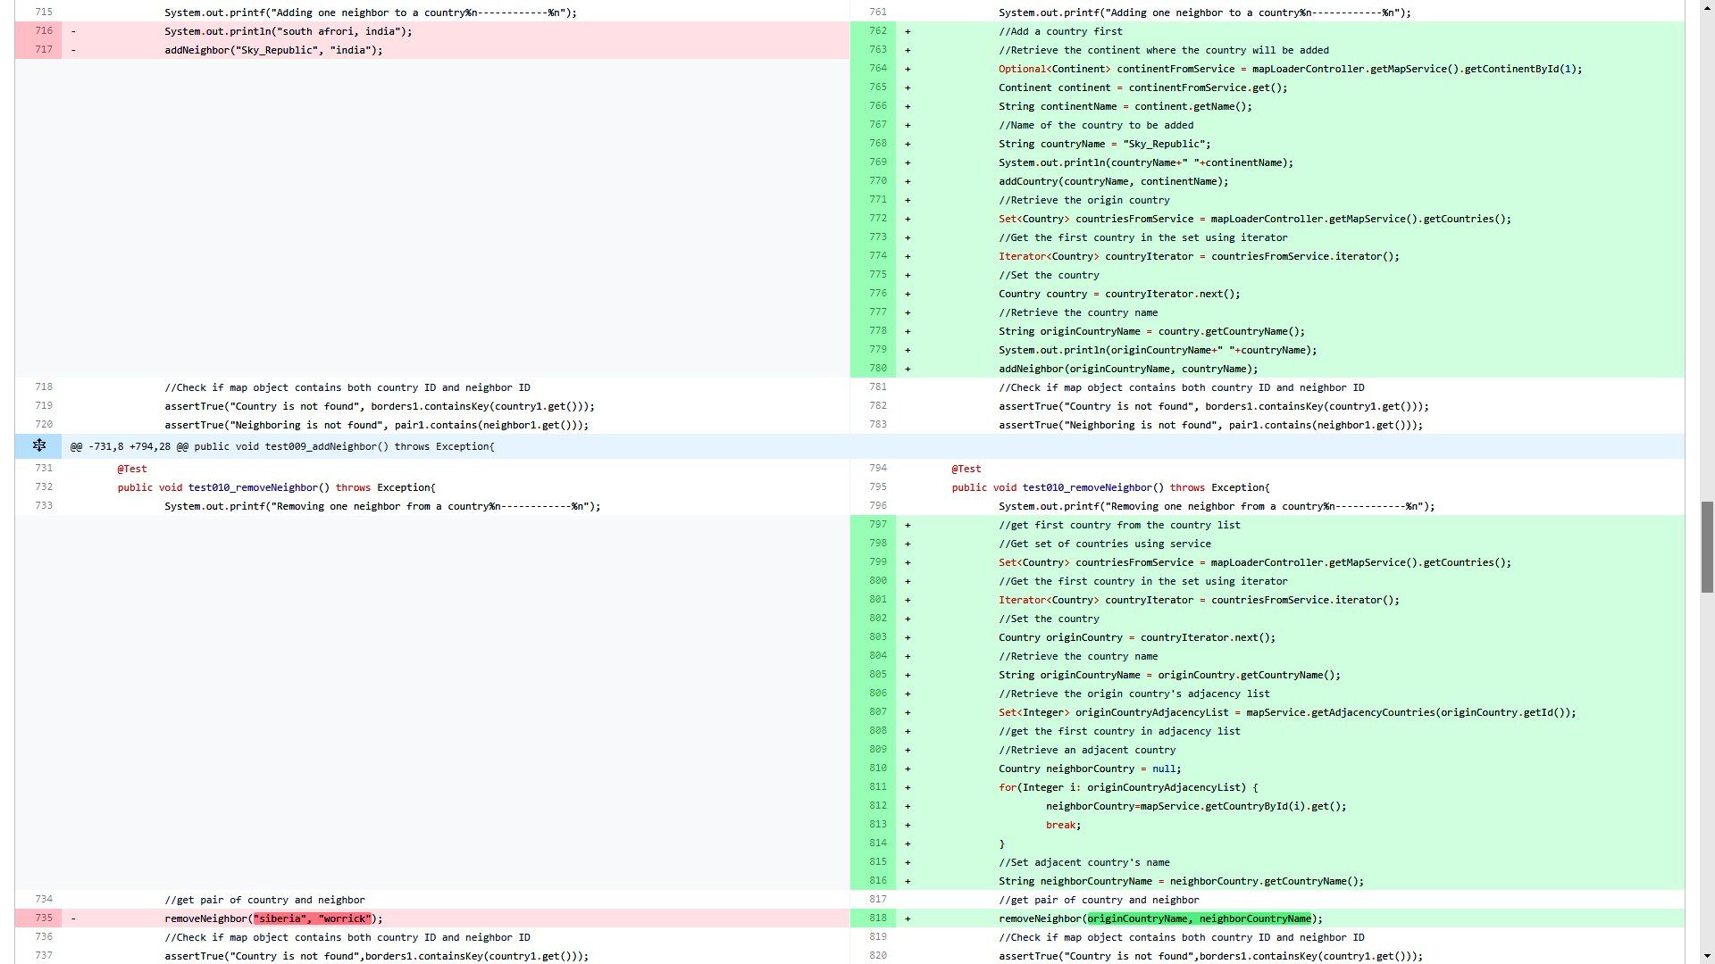

Using set and iterator types in conjunction to completely eliminate to remove any hard coded continents and countries, instead getting them from map file.

Architecture for Build 3 making use of different patterns